2015 COACHES’ Mentoring Challenge
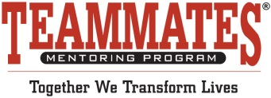

Write-up ideas to include in your athletic event flyers and programs

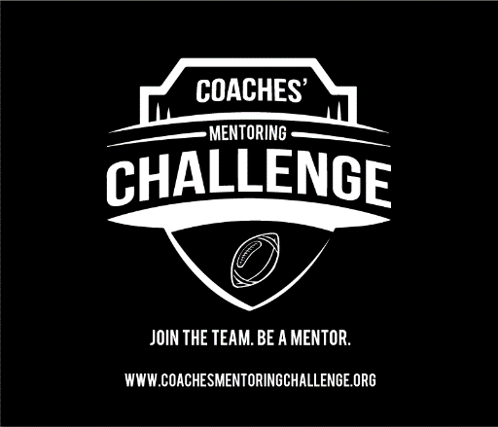
We want you to join our team of mentors! Every fall, the Coaches’ Mentoring Challenge kick starts our year of mentor recruitment. Join the challenge—we need volunteers like you, to help grow our program and make an impact of the life of a young person.
Become a mentor with TeamMates Mentoring Program today! To learn more about becoming a TeamMates mentor in your community, please contact (add local chapter contact information) (add your chapter logo)

We’re recruiting you! Make an impact on the life of a young person by becoming a TeamMates mentor.
Join the challenge. Become a mentor with TeamMates Mentoring Program today! To learn more about becoming a TeamMates mentor in your community, please contact (add local chapter contact information) (add your chapter logo)

