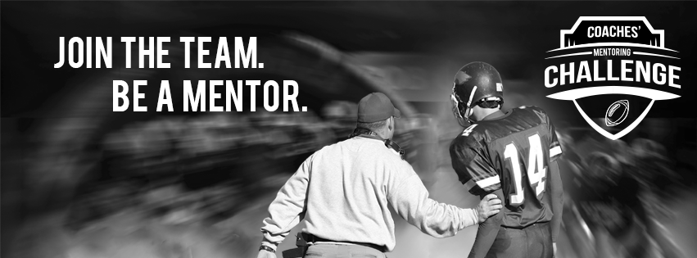
2015 COACHES’ Mentoring Challenge

Coaches’ Mentoring Challenge 2015 Social Media How-To
Campaign Dates: August 1-November 30, 2015
Social Media Resources for your Chapter
Remember to use #CoachesMentoringChallenge in every post, so that we can share your messages! Consider using the graphics below to accompany your messages.
To save these graphics for use, please right-click and select “Save as Picture”.
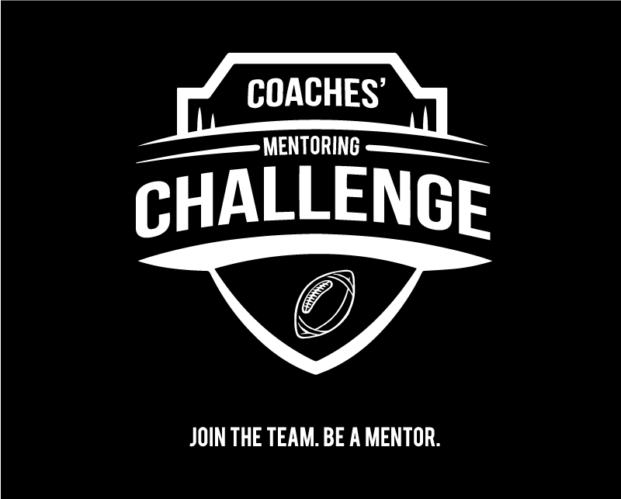
Sample Tweets
Join the team! Be a #mentor in the #CoachesMentoringChallenge and make an impact in [STATE]. http://bit.ly/1uU4I2T @TeamMates1Hour
The #MentoringEffect strengthens our team, our campus and our communities. Go @TeamMates1Hour! http://bit.ly/1uU4I2T
Caring role models make a difference for young people on and off the field. Be a #mentor! #CoachesMentoringChallenge! http://bit.ly/1uU4I2T @TeamMates1Hour
We want you on our team! Join the #CoachesMentoringChallenge to support young people in [STATE]. http://bit.ly/1uU4I2T @TeamMates1Hour
Over a dozen @BigTenConf and @Big12Conference coaches are participating in the #CoachesMentoringChallenge. Join the team! http://bit.ly/1uU4I2T
Mentored youth are 81% more likely to join in activities. http://bit.ly/1uU4I2T #CoachesMentoringChallenge @TeamMates1Hour
Mentored youth are 55% more likely to be college enrolled http://bit.ly/1uU4I2T #CoachesMentoringChallenge @TeamMates1Hour
Mentored youth are 130% more likely to lead in sport/club. http://bit.ly/1uU4I2T #CoachesMentoringChallenge @TeamMates1Hour
Mentored students are 36% more likely to stay in school. http://bit.ly/1uU4I2T #CoachesMentoringChallenge @TeamMates1Hour
1 in 3 young people grow up without a #mentor. You can change that. Be a mentor! http://bit.ly/1uU4I2T #CoachesMentoringChallenge @TeamMates1Hour
Sample Facebook Posts
To save these graphics for use, please right-click and select “Save as Picture”.

Have you joined “Team Mentoring”? 1 in 3 young people grow up without a mentor. You can make a difference in our community! Be a part of the Coaches’ Mentoring Challenge and support young people in [STATE]. http://bit.ly/1uU4I2T #CoachesMentoringChallenge
More than a dozen Big Ten Conference and Big 12 Conference coaches are participating in the Coaches’ Mentoring Challenge in support of young people in their local communities. Want to make an impact? Join the [STATE] team! http://bit.ly/1uU4I2T #CoachesMentoringChallenge
Campaign Overview
MENTOR: The National Mentoring Partnership’s (MENTOR) report, The Mentoring Effect, found through the first-ever nationally representative survey of young people that one in three will grow up without connecting with a mentor. The survey also found a powerful mentoring effect demonstrated by the experiences of young people who participated in the survey. It is linked to improved academic, social and economic prospects, and strengthens our communities and our nation. As just one example of the report findings, at-risk young adults who had a mentor are 55% more likely to be enrolled in college than those who did not have a mentor.

For the past seven years, college coaches at an increasing number of institutions, who know first-hand the impact of this powerful asset, have demonstrated their commitment to closing the mentoring gap by participating in the Coaches’ Mentoring Challenge. This campaign began as a friendly competition between Coach Tom Osborne at the University of Nebraska and Coach Bill Snyder at Kansas State in 2008 with the goal of rallying new volunteers for mentoring programs in their communities and states.
The campaign success is due in part to the collaborative partnerships formed between participating universities and MENTOR’s affiliate Mentoring Partnerships in their area, and other nonprofit partners serving young people. Since its kickoff, teams in seven states have joined and during the 2014 Coaches’ Mentoring Challenge, over 10,000 fans stepped up.
In 2015, the Big Ten Conference will become part of this team effort – providing a national platform for raising awareness. The 2015 Coaches’ Mentoring Challenge kicks off on August 1 and runs through November 30, with results released during the first week in December. Through this effort, participating coaches and universities are making meaningful contributions to the communities they call home.
The goal this year: 15,000 new mentors signed up during the 2015 Coaches’ Mentoring Challenge!

