Jersey Day Ask Email
Subject Line: October 16--Become their “Biggest Fan” on Jersey Day for TeamMates
Businesses across Nebraska and Iowa are asking their employees to put on their favorite team jersey on Friday, October 16th, to show their support of the TeamMates Mentoring Program. Join in the fun by inviting your staff to make a $10 donation to the TeamMates Mentoring Program and wear their favorite team jersey on Oct. 16th.

Any sport, any team, at any level! Just show your spirit by wearing a jersey to work and be somebody’s “Biggest Fan”.

Over 7,500 youth in the TeamMates Program see their “Biggest Fan” once a week during the school year when they meet with their TeamMates mentor. Our mentees receive support and encouragement as their mentor advocates and cheers them on through their school years providing hope and a positive vision for their future.

Thanks for being TeamMates “Biggest Fan”,

(Board or Coordinator Signature and Name)

START HERE TO BECOME THEIR “BIGGEST FAN”
To make a difference in the lives of our TeamMates matches sign up today for Jersey Day by contacting our TeamMates Coordinator at (insert phone number) or (insert email) to receive the information you need to make Jersey Day a success.

Jersey Day Email with Step by Step Instructions
For Participating Businesses
Subject: Thanks for being a part of Jersey Day for TeamMates – Here’s how to get started!
You’ve Got Spirit, yes you DO! Thanks again for supporting over 7,500 matches in the TeamMates Mentoring Program by taking part in Jersey Day for TeamMates on Friday, October 16th.
Follow these simple steps before, during, and after JERSEY DAY.
1.) BEFORE: Say it Loud, Say It Proud by using any of the promotional materials attached in this email to let your staff know about the day: Email to your Employees, Posters for your Office and/or Blurb for Intranet/Employee Newsletter/Other Internal Communication.

2.) DURING JERSEY DAY: We are so impressed with your Team Spirit. Feel free to make this day one your staff will be asking if you are going to participate in next year, by holding a pep rally, breaking out the tailgating games, grilling hot dogs, tossing around pom-poms, megaphones and spirit beads or giving out some awesome raffle prizes.

Celebrate Giving Back to the kids in your community by posting the included social media message on your company website, Facebook, twitter or Instagram account. Feel free to snap a photo of your staff in their jerseys and use #JerseyDay4TM #WeRUrBiggestFan You can even print the Jersey Logos on sticker paper to let your participating staff show why they are wearing their favorite jersey.

3.) AFTER JERSEY DAY: When Jersey Day comes to an end and you have collected your donations, you can send them into TeamMates, along with the name and address of your employee donors if they would like a tax acknowledgement, by mailing a check by Nov. 1st. to:
TeamMates Mentoring Program Jersey Day
(Coordinator Address Information)
or make a credit card donation online at: https://donatenow.networkforgood.org/1438013 In the donation dedicated to box, please type Jersey Day. Your gift will support all 7,500 TeamMates matches. (If you want your donation to go to a specific TeamMates Chapter, select that Chapter from the drop down box.)

If your company has a matching gift program, please consider matching the contribution of your employees.

Thanks again for being somebody’s ”Biggest Fan”,
(Coordinator Contact Information)

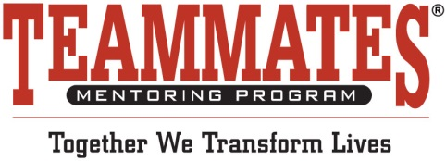
Media Contact:
(Coordinator Contact Info.)

We Have Spirit! Yes, We Do!
Local Businesses Demonstrate Support for Mentoring

For Immediate Release Oct. 20, 2015 (CITY, STATE) – On Friday, Oct. 16th employees from several area businesses participated in Jersey Day and put on their favorite team jersey in support of TeamMates Mentoring Program.

For just a $10 donation, local employees donned jerseys from all athletic levels, a variety of different sports and all types of team colors. Employees came together in support of the youth involved in the TeamMates Mentoring Program.
Across the TeamMates organization, over 7,500 youth in the TeamMates Mentoring Program see their “Biggest Fan” once a week during the school year when they meet with their TeamMates mentor. Mentees receive support and encouragement as their mentor advocates and cheers them on through their school years providing hope and a positive vision for their future at the post-secondary level.

TeamMates Mentoring Program of (Chapter Name) is pleased with the support of the local business community and their efforts to generate awareness for the need of mentors and financial support for the Chapter. (Insert other local information).

“Jersey Day was a huge success across our organization and has allowed our communities the chance to recruit new mentors and financial supporters to help serve their local matches,” shared TeamMates Executive Director, Suzanne Hince.

For more information on how you can support the local TeamMates Chapter, please contact: (Local Contact Information)

The TeamMates Mentoring Program was founded in 1991 by Tom and Nancy Osborne to provide support and encouragement to school-aged youth. The TeamMates Mentoring Program currently serves close to 7,500 youth in more than 130 chapters across Nebraska, Iowa and California. To be a mentor, call 1-877-531-8326 or go to www.teammates.org

Media Contact:
(Coordinator Contact Info)

Team Spirit Spreads Across the Community
As Area Businesses Participate in Jersey Day for TeamMates Mentoring Program
For Immediate Release October 1, 2015 (CITY, STATE) – On Friday, October 16th you will see employees all across the community wearing their favorite team jersey in support of Jersey Day for the TeamMates Mentoring Program.

To raise awareness and financial support for the program, area businesses are being asked to encourage their staff to join in on the special day to promote the TeamMates Mentoring Program. With a ten dollar donation to the program, employees can wear the favorite high school, college or professional team jersey.

Over 7,500 youth in the TeamMates Mentoring Program see their “Biggest Fan” once a week during the school year when they meet with their TeamMates mentor. Mentees receive support and encouragement as their mentor advocates and cheers them on through their school years providing hope and a positive vision for their future at the post-secondary level.

TeamMates Mentoring Program of (Chapter Name) is excited to have businesses in the community signing up to show their team spirit as part of Jersey Day on October 16th and support the local mentoring program.

“Jersey Day is a great way for local businesses to show their support of our programs across our organization and it is a great way for more people to learn about our program including the need for mentors and financial support,” shared TeamMates Executive Director, Suzanne Hince.

For more information on how you can be a part of Jersey Day or support the local TeamMates Chapter, please contact: (Local Contact Information)

The TeamMates Mentoring Program was founded in 1991 by Tom and Nancy Osborne to provide support and encouragement to school-aged youth. The TeamMates Mentoring Program currently serves close to 7,500 youth in 131 chapters across Nebraska, Iowa and California. To be a mentor, call 1-877-531-8326 or go to www.teammates.or

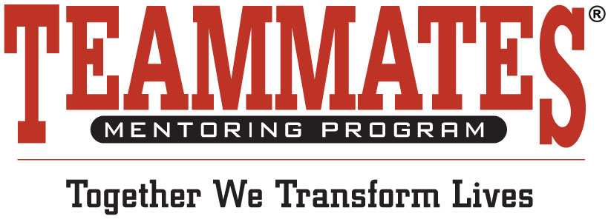

PSA FOR JERSEY DAY FOR TEAMMATES

Co-worker One: So what’s all the talk around the water cooler this morning?

Co-Worker Two: On Friday, Oct. 16th we don’t have to wear our normal business attire to work, because we are participating in Jersey Day for the TeamMates Mentoring Program.

Co-Worker One: What??! I don’t have to wear this tie Oct. 16th?

Co-Worker Two: No, just sign up at the front office and for just a $10 donation to the TeamMates Mentoring Program you can wear your favorite team Jersey on Oct. 16th. Just please don’t pull out your old high school jersey, as I’m sure it might smell like moth balls.

Announcer: Contact your school’s local TeamMates Program Coordinator today to find out how your business can participate in Jersey Day for the TeamMates Mentoring Program and show your community your Team Spirit.

