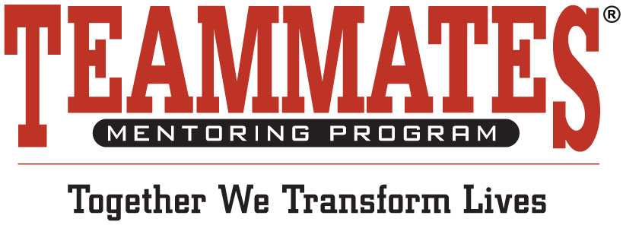

**Jersey Day Details**

This program is a way for you to engage your

business community to support TeamMates in a

way that allows each employee of a business to

participate in a FUN way. On Friday Oct. 16th

employees can come to work wearing their

favorite team jersey by making a $10 donation

to support your TeamMates Chapter.

***Complete these easy steps with your board:***

 1.) ***Last Week in August*** - Make a list of businesses and contacts that you can email

or send a letter to about the program.

2.) ***September 1st*** - Send the Jersey Day Ask Letter/Email to your contact list.

 3.) ***First Two Weeks in September.*** - When a business responds to confirm participation in Jersey Day, email them the Step by Step Instructions and supporting materials including:

* Email from the Business to their employees
* Poster for Jersey Day
* Blurb for business website, intranet, newsletter promotion, etc.
* Social Media Posts for Business to send out on Jersey Day
* Sticker template for business to share with employees who participate

Follow up with a phone call to businesses to confirm their participation in Jersey Day, be sure to

confirm board member’s businesses and don’t forget your school.

4.) ***October 1st and October20th*** - Send out Jersey Day Press Release to your local media prior to and post event with results.

5.) ***Nov. 15th*** - Follow TeamMates guidelines for tracking donations and send out thank

you notes to those businesses who participated.