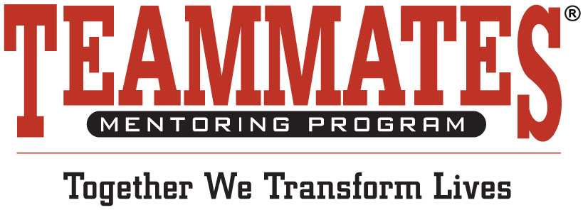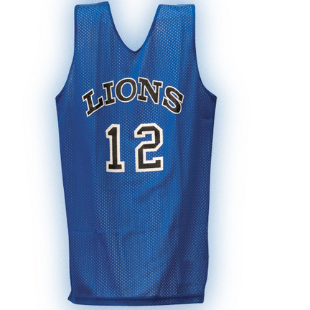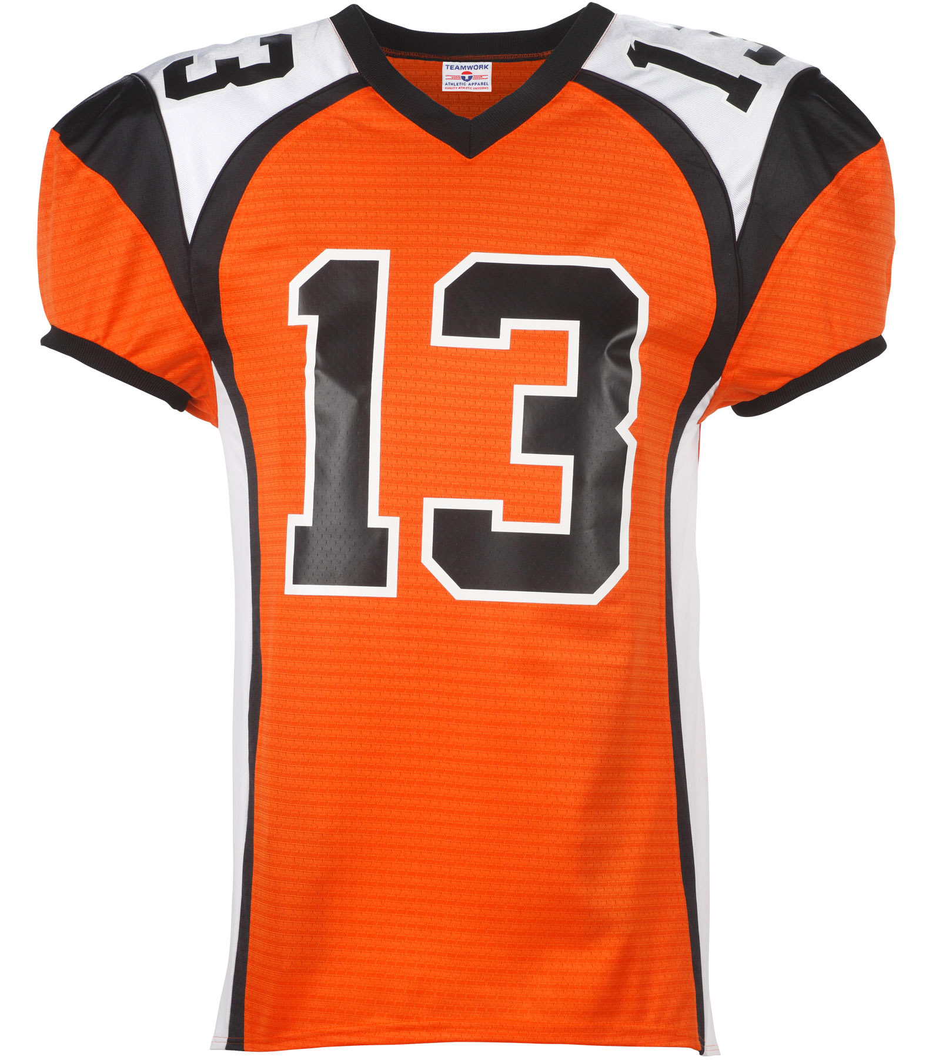

**For just $10 wear your**

**favorite team jersey to**

**work on Friday, October 16th**

**in support of the**

**TeamMates Mentoring Program.**

Just turn your $10 donation in by Oct. 16.

For questions, please contact:

(Business Contact Information)