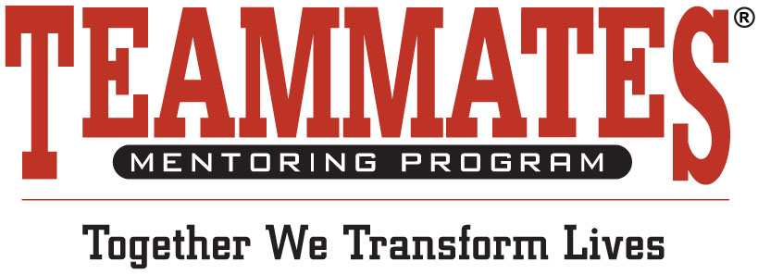

**Social Media Post for Jersey Day for**

**Participants**

We have spirit! Yes, we do! We have spirit! How about you?

**(Company Name)** employees are participating in

Jersey Day for the TeamMates Mentoring Program.

#JerseyDay4TM #WeRUrBiggestFan