Multiple Intelligences – by Dr. Howard Gardner

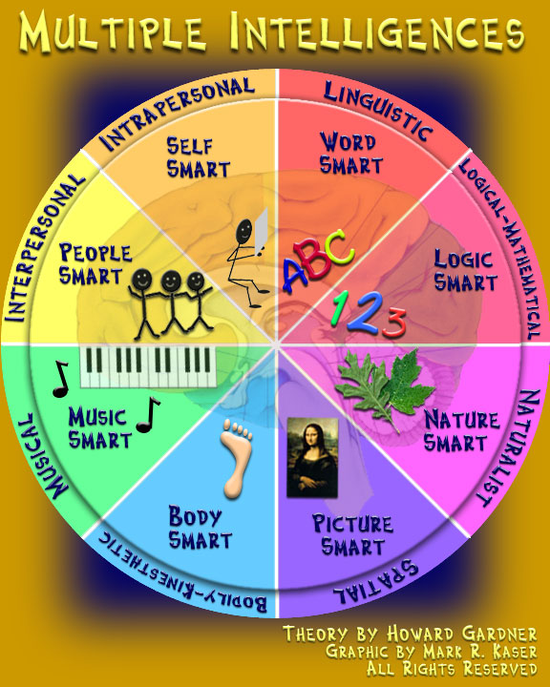

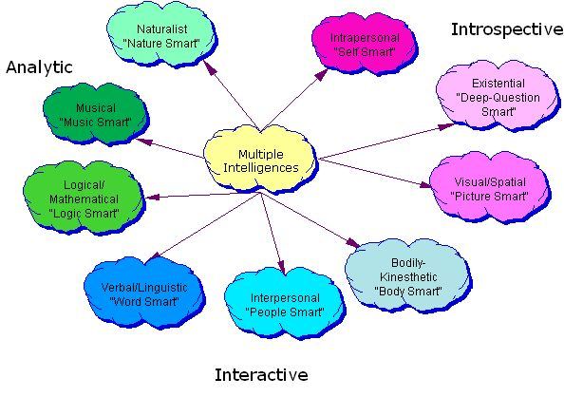

What makes “YOU” smart?!?!

Spatial
This area deals with spatial judgment and the ability to visualize with the mind's eye. Students think in terms of physical space, as do architects and sailors. Very aware of their environments. They like to draw, do jigsaw puzzles, read maps, daydream. They can be taught through drawings, verbal and physical imagery. Tools include models, graphics, charts, photographs, drawings, 3-D modeling, video, videoconferencing, television, multimedia, texts with pictures/charts/graphs. Careers which suit those with this type of intelligence include artists, designers and architects. A spatial person is also good with puzzles.

Linguistic
This area has to do with words, spoken or written. These learners have highly developed auditory skills and often think in words. They like reading, playing word games, making up poetry or stories. They can be taught by encouraging them to say and see words, read books together. Tools include computers, games, multimedia, books, tape recorders, and lecture. They are typically good at reading, writing, telling stories and memorizing words along with dates. They tend to learn best by reading, taking notes, listening to lectures, and by discussing and debating about what they have learned. Those with verbal-linguistic intelligence learn foreign languages very easily as they have high verbal memory and recall, and an ability to understand and manipulate syntax and structure.

Logical-mathematical
This area has to do with logic, abstractions, reasoning and calculating. Students think conceptually, abstractly and are able to see and explore patterns and relationships. They like to experiment, solve puzzles, ask cosmic questions. They can be taught through logic games, investigations, mysteries. They need to learn and form concepts before they can deal with details. While it is often assumed that those with this intelligence naturally excel in mathematics, chess, computer programming and other logical or numerical activities, a more accurate definition places less emphasis on traditional mathematical ability and more on reasoning capabilities, recognizing abstract patterns, scientific thinking and investigation and the ability to perform complex calculations. It correlates strongly with traditional concepts of "intelligence" or IQ.

Bodily-kinesthetic
The core elements of the bodily-kinesthetic intelligence are control of one's bodily motions and the capacity to handle objects skillfully (206). Gardner elaborates to say that this intelligence also includes a sense of timing, a clear sense of the goal of a physical action, along with the ability to train responses so they become like reflexes.
In theory, people who have bodily-kinesthetic intelligence should learn better by involving muscular movement (e.g. getting up and moving around into the learning experience), and are generally good at physical activities such as sports or dance. They may enjoy acting or performing, and in general they are good at building and making things. They often learn best by doing something physically, rather than by reading or hearing about it. Those with strong bodily-kinesthetic intelligence seem to use what might be termed muscle memory - they remember things through their body such as verbal memory.
Careers that suit those with this intelligence include: athletes, pilots, dancers, musicians, actors, surgeons, doctors, builders, police officers, and soldiers. Although these careers can be duplicated through virtual simulation, they will not produce the actual physical learning that is needed in this intelligence.

Musical
This area has to do with sensitivity to sounds, rhythms, tones, and music. They love music, but they are also sensitive to sounds in their environments. They may study better with music in the background. They can be taught by turning lessons into lyrics, speaking rhythmically, tapping out time. Tools include musical instruments, music, radio, stereo, CD-ROM, multimedia. Students with a high musical intelligence normally have good pitch and may even have absolute pitch, and are able to sing, play musical instruments, and compose music. Since there is a strong auditory component to this intelligence, those who are strongest in it may learn best via lecture. Language skills are typically highly developed in those whose base intelligence is musical. In addition, they will sometimes use songs or rhythms to learn. They have sensitivity to rhythm, pitch, meter, tone, melody or timbre.
Careers that suit those with this intelligence include instrumentalists, singers, conductors, disc-jockeys, orators, writers and composers.

Interpersonal
This area has to do with interaction with others. These students learn through interaction. They have many friends, empathy for others, street smarts. They can be taught through group activities, seminars, dialogues. Tools include the telephone, audio conferencing, time and attention from the instructor, video conferencing, writing, computer conferencing, E-mail. In theory, people who have a high interpersonal intelligence tend to be extroverts, characterized by their sensitivity to others' moods, feelings, temperaments and motivations, and their ability to cooperate in order to work as part of a group. They communicate effectively and empathize easily with others, and may be either leaders or followers. They typically learn best by working with others and often enjoy discussion and debate. Careers that suit those with this intelligence include sales, politicians, managers, teachers and social workers.

Intrapersonal
This area has to do with introspective and self-reflective capacities. These learners tend to shy away from others. They're in tune with their inner feelings; they have wisdom, intuition and motivation, as well as a strong will, confidence and opinions. They can be taught through independent study and introspection. Tools include books, creative materials, diaries, privacy and time. They are the most independent of the learners. People with intrapersonal intelligence are intuitive and typically introverted. They are skillful at deciphering their own feelings and motivations. This refers to having a deep understanding of the self; what your strengths/ weaknesses are, what makes you unique, you can predict your own reactions/ emotions. Careers which suit those with this intelligence include philosophers, psychologists, theologians, lawyers, and writers. People with intrapersonal intelligence also prefer to work alone.

Naturalistic
This area has to do with nurturing and relating information to one’s natural surroundings. Careers which suit those with this intelligence include naturalists, farmers and gardeners.

Existential
Some proponents of multiple intelligence theory proposed spiritual or religious intelligence as a possible additional type. Gardner did not want to commit to a spiritual intelligence, but suggested that an "existential" intelligence may be a useful construct. Students have the ability to contemplate phenomena or questions beyond sensory data, such as the infinite and infinitesimal. Careers or callings which suit those with this intelligence include shamans, priests, mathematicians, physicists, scientists, cosmologists and philosophers.

"The Distance Learning Technology Resource Guide”
Frames of Mind: The Theory of Multiple Intelligences by Dr. Howard Gardner

